Lab 05:
Exercise

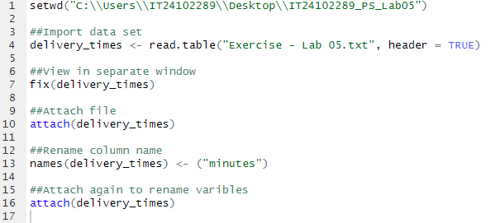
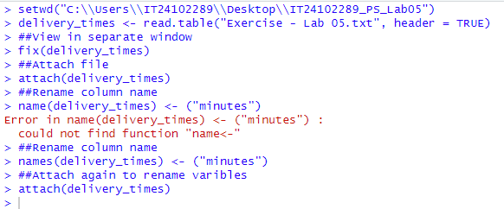

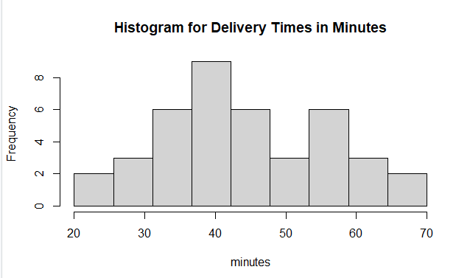
- Roughly Symmetrical:
The distribution appears roughly symmetric around the center (around 40–45 minutes). The bars on the left and right taper off somewhat evenly.

Unimodal:
There's a single prominent peak (mode) around 35–40 minutes, suggesting that most deliveries are centered around that time range.

No Strong Skewness:
There is no strong skew (neither left nor right). The tails on both ends look balanced, though the right tail (60–70 minutes) is slightly longer — if anything, there might be a slight right skew, but it's very mild.

No Significant Outliers or Gaps:
There are no noticeable gaps or isolated bars, suggesting a continuous spread of delivery times.

